IDA’s New Infomap Connects the Who, What, and How of Structured Literacy
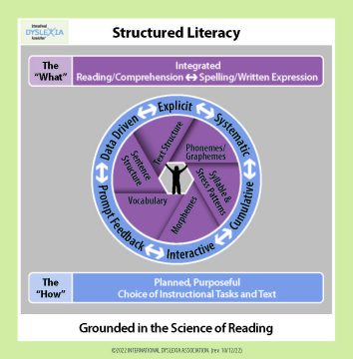

IDAThe term Structured Literacy (SL) is new to many, but the practices it references are not. SL is both WHAT to teach (the content) and HOW to teach it (the methods or principles of instruction). IDA coined the term in the early 2000s to provide a brief, descriptive, name for approaches rooted in Orton-Gillingham-based programs and Multi-Sensory Structured Language Education (MSLE).
Science of Reading (SOR) is another relatively new term, but it describes work that IDA and others have championed for a long time—research on reading (both the WHAT and the HOW). Sometimes SL and SOR are used interchangeably, but they are not the same. SL is informed by the SOR, which is all the research on reading to date. That’s why IDA’s new infomap is called “Structured Literacy: Grounded in the Science of Reading.”
IDA developed this infomap to clarify the distinction between SL and SOR, add more layers (for example, writing) to earlier IDA infographics, and emphasize the importance of integrating all these elements during instruction, as illustrated by the wheel. We’re calling this new, detailed version an infomap because it will link to other resources to more fully support new and experienced educators in delivering instruction to struggling readers, including those with dyslexia.
This new infomap was created to support educators trained in programs aligned with IDA’s Knowledge and Practice Standards for Teachers of Reading (KPS) and to inspire other educators to seek that training. It is not a comprehensive scope and sequence for intervention; however, it does provide examples and supplemental materials to support educators (the Who) implementing interventions based on the KPS.
Download the infomap and infographic here and share it with your colleagues. You’ll also find it in IDA’s digital library, ShopIDA.org, and IDA’s website:DyslexiaIDA.org

